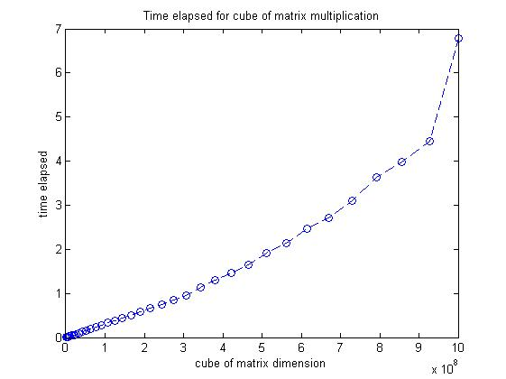

From the plot I generate from Matlab, we could see as matrix dimension increases, time elapsed longer. Especially when matrix dimension is greater than 900, it cost significant amount of time to figure out the matrix multiplication.